PPP Frame

🧱 What Is a PPP Frame?
# Source: AI Source: Provided by: [Data Path: Persons Table -> ID Column: 1, Name_En Column: Motasem Essam] -> From: [ChatGPT] on [1/16/2026]
PPP stands for Point-to-Point Protocol — a Layer 2 (Data Link Layer) protocol used to transmit data between two directly connected nodes, such as over:
- Dial-up modems ☎️
- Serial links
- DSL connections
- VPN tunnels
A PPP frame is the basic unit of data transfer in PPP, encapsulating Layer 3 protocols (like IP packets) for transmission.

🧠 Simple Definition:
# Source: AI Source: Provided by: [Data Path: Persons Table -> ID Column: 1, Name_En Column: Motasem Essam] -> From: [ChatGPT] on [1/16/2026]
A PPP frame is a data structure used to wrap packets (like IP) so they can be transmitted reliably between two directly connected devices using the Point-to-Point Protocol.

📦 PPP Frame Format (Standard HDLC-like Structure)
# Source: AI Source: Provided by: [Data Path: Persons Table -> ID Column: 1, Name_En Column: Motasem Essam] -> From: [ChatGPT] on [1/16/2026]
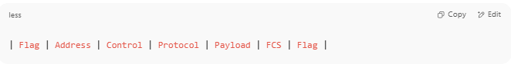
| Flag | Address | Control | Protocol | Payload | FCS | Flag |

🔍 Breakdown of Fields
# Source: AI Source: Provided by: [Data Path: Persons Table -> ID Column: 1, Name_En Column: Motasem Essam] -> From: [ChatGPT] on [1/16/2026]
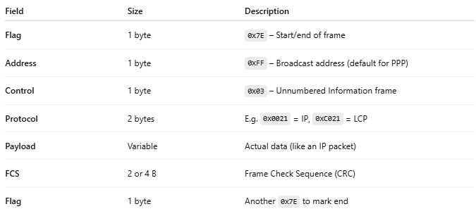

Field | Size | Description
Flag | 1 byte | 0x7E – Start/end of frame
Address | 1 byte | 0xFF – Broadcast address (default for PPP)
Control | 1 byte | 0x03 – Unnumbered Information frame
Protocol | 2 bytes | E.g. 0x0021 = IP, 0xC021 = LCP
Payload | Variable | Actual data (like an IP packet)
FCS | 2 or 4 B | Frame Check Sequence (CRC)
Flag | 1 byte | Another 0x7E to mark end

📄 Example PPP Frame (Encapsulating an IPv4 Packet)
# Source: AI Source: Provided by: [Data Path: Persons Table -> ID Column: 1, Name_En Column: Motasem Essam] -> From: [ChatGPT] on [1/16/2026]
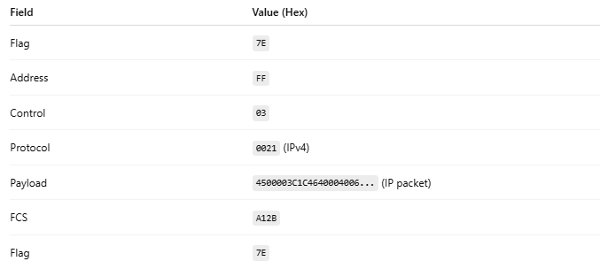

Field | Value (Hex)
Flag | 7E
Address | FF
Control | 03
Protocol | 0021 (IPv4)
Payload | 4500003C1C4640004006... (IP packet)
FCS | A12B
Flag | 7E

🧱 PPP Frame Format – Visual Example
# Source: AI Source: Provided by: [Data Path: Persons Table -> ID Column: 1, Name_En Column: Motasem Essam] -> From: [ChatGPT] on [1/16/2026]
Let’s assume this PPP frame is encapsulating a basic IPv4 packet.
Sure! Here's a 🧠 visual example of a PPP (Point-to-Point Protocol) frame, similar to how Ethernet or Wi-Fi frames were illustrated earlier.
Let’s assume this PPP frame is encapsulating a basic IPv4 packet.
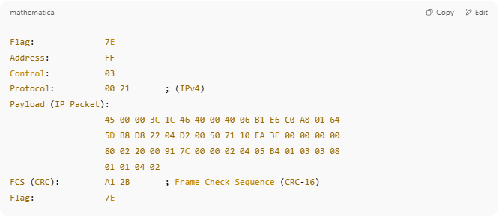
Flag: 7E
Address: FF
Control: 03
Protocol: 00 21 ; (IPv4)
Payload (IP Packet):
45 00 00 3C 1C 46 40 00 40 06 B1 E6 C0 A8 01 64
5D B8 D8 22 04 D2 00 50 71 10 FA 3E 00 00 00 00
80 02 20 00 91 7C 00 00 02 04 05 B4 01 03 03 08
01 01 04 02
FCS (CRC): A1 2B ; Frame Check Sequence (CRC-16)
Flag: 7E

📄 Field-by-Field Breakdown
# Source: AI Source: Provided by: [Data Path: Persons Table -> ID Column: 1, Name_En Column: Motasem Essam] -> From: [ChatGPT] on [1/16/2026]
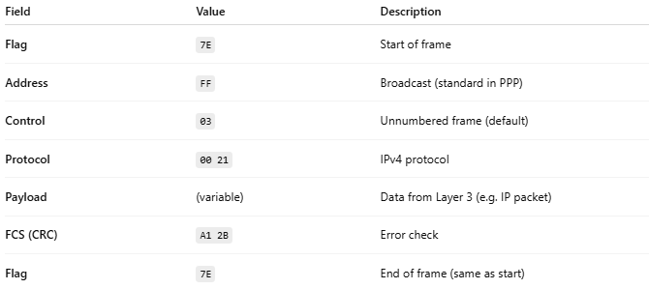
Field | Value | Description
Flag | 7E | Start of frame
Address | FF | Broadcast (standard in PPP)
Control | 03 | Unnumbered frame (default)
Protocol | 00 21 | IPv4 protocol
Payload | (variable) | Data from Layer 3 (e.g. IP packet)
FCS (CRC) | A1 2B | Error check
Flag | 7E | End of frame (same as start)

✅ Summary Table
# Source: AI Source: Provided by: [Data Path: Persons Table -> ID Column: 1, Name_En Column: Motasem Essam] -> From: [ChatGPT] on [1/16/2026]
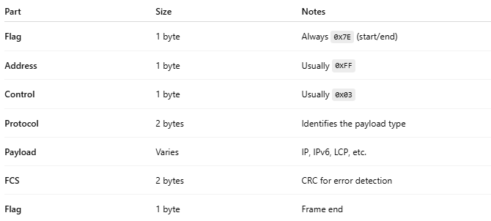
Part | Size | Notes
Flag | 1 byte | Always 0x7E (start/end)
Address | 1 byte | Usually 0xFF
Control | 1 byte | Usually 0x03
Protocol | 2 bytes | Identifies the payload type
Payload | Varies | IP, IPv6, LCP, etc.
FCS | 2 bytes | CRC for error detection
Flag | 1 byte | Frame end

🧠 Think of it like this:
# Source: AI Source: Provided by: [Data Path: Persons Table -> ID Column: 1, Name_En Column: Motasem Essam] -> From: [ChatGPT] on [1/16/2026]
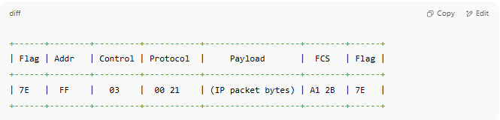
+------+--------+---------+-----------+-------------------+--------+------+
| Flag | Addr | Control | Protocol | Payload | FCS | Flag |
+------+--------+---------+-----------+-------------------+--------+------+
| 7E | FF | 03 | 00 21 | (IP packet bytes) | A1 2B | 7E |
+------+--------+---------+-----------+-------------------+--------+------+

🛠 Common PPP Protocol Types
# Source: AI Source: Provided by: [Data Path: Persons Table -> ID Column: 1, Name_En Column: Motasem Essam] -> From: [ChatGPT] on [1/16/2026]
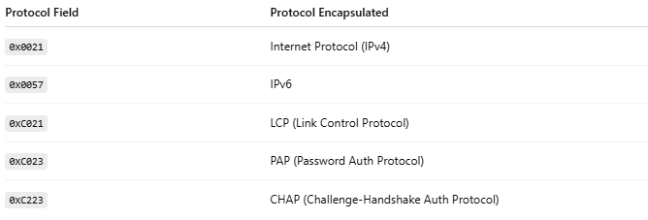

Protocol Field | Protocol Encapsulated
0x0021 | Internet Protocol (IPv4)
0x0057 | IPv6
0xC021 | LCP (Link Control Protocol)
0xC023 | PAP (Password Auth Protocol)
0xC223 | CHAP (Challenge-Handshake Auth Protocol)

✅ Summary
# Source: AI Source: Provided by: [Data Path: Persons Table -> ID Column: 1, Name_En Column: Motasem Essam] -> From: [ChatGPT] on [1/16/2026]
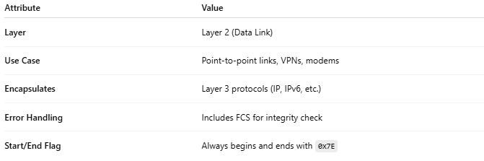

Attribute | Value
Layer | Layer 2 (Data Link)
Use Case | Point-to-point links, VPNs, modems
Encapsulates | Layer 3 protocols (IP, IPv6, etc.)
Error Handling | Includes FCS for integrity check
Start/End Flag | Always begins and ends with 0x7E

